Phase 7 — SQL Server + Entity Framework Core – Theory
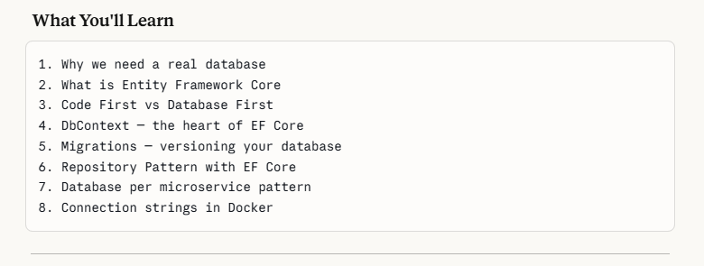
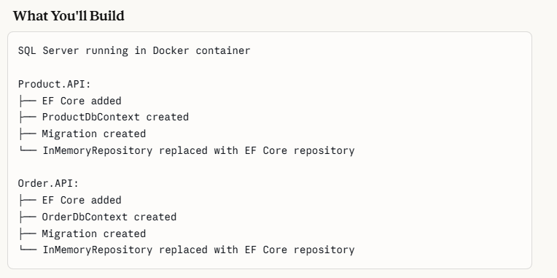

What is entity Framework Core?
EF Core translates the Csharp code into sql automatically
EF core is an ORM – Object Relational Mapper
Ef core solves the problem of writing sql queries in the program
Without EF Core you write raw SQL:

-- Get all products
SELECT Id, ProductId, Prod_Name, Price, Stock FROM Products
WHERE Category = 'Electronics'
-- Insert product
INSERT INTO Products (Prod_Name, Price, Stock)
VALUES ('Laptop', 1299.99, 25)
-- Update product
UPDATE Products SET Stock = 20 WHERE Id = 1
But with EF core we write the code is csharp as
// Get all products
var products = await context.Products
.Where(p => p.Category == "Electronics") .ToListAsync();
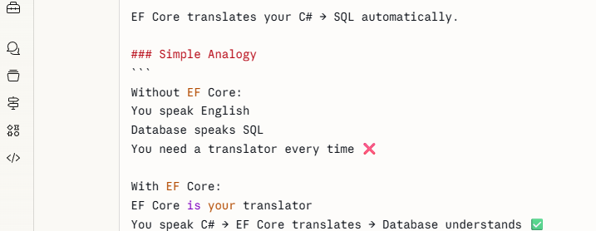
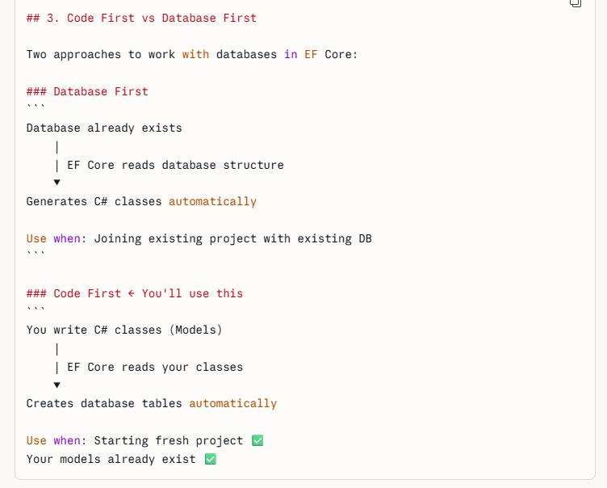

DB CONTEXT –
- It is the heart of the EF core
- It is the bridge between the C# code and the database
- It is like a warehouse manager
- 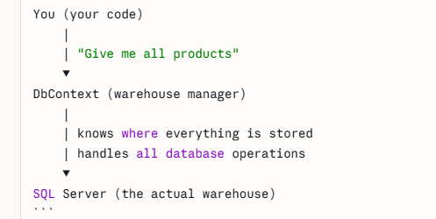

- What DbContext Does
- Connects to the database
- Tracks changes made to your objects
- Transalates LINQ queries -> SQL
- Saves changes to database
- Manages transactions.
- DBset = > each DBset is one database table
- Eg public DbSet<Product> Products { get; set; }

MIGRATIONS

Migration is a **snapshot of your database schema changes** over time.
Think of it like
**Git for your database**: ```
Git: commit 1 → "Added user model"
commit 2 → "Added product model"
commit 3 → "Added price column"

Migrations:
migration 1 → "Created Products table"
migration 2 → "Created Orders table"
migration 3 → "Added Category column to Products"

### Why Migrations are Important ``
` Without migrations:
Team member A adds new column locally
Team member B doesn't know about it
Production database is different from development

❌ With migrations:
Migration file committed to Git
Team member B pulls code → runs migration
Everyone has same database structure
✅ Production updated safely ✅

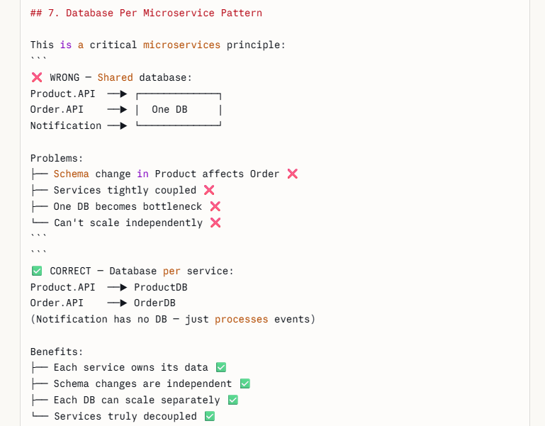

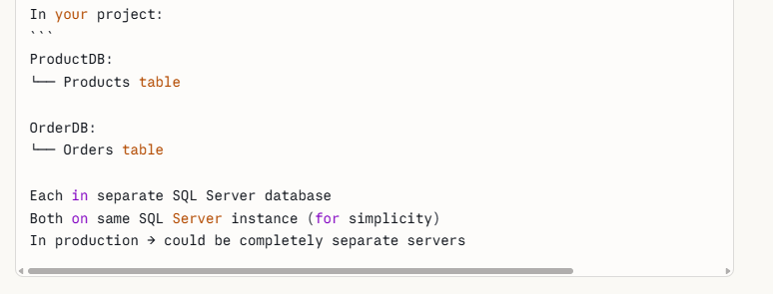
- Here the sql server needs to be run as a docker container
- Like rabbit mq and kafka running
- 

 